Download GIT:

1. Go to <https://github.com/git-for-windows/git/releases/download/v2.13.1.windows.2/Git-2.13.1.2-64-bit.exe>
2. When prompted, check the following:

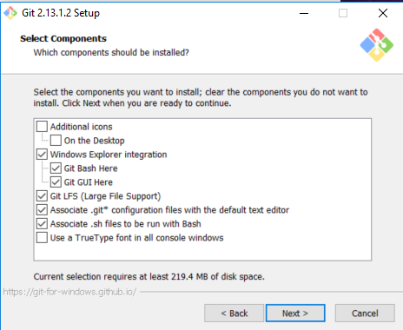

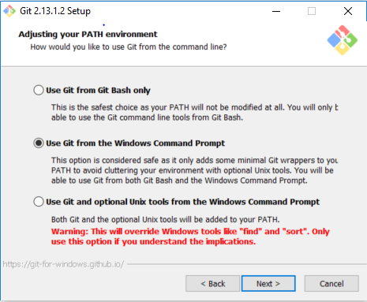

1. Next, next, next until installation is done.

Generate SSH keys

1. Open Git Bash
2. In the console, type ssh-keygen –t rsa
3. Follow the on-screen instructions
4. Done!

Download Webstorm:

1. Go to <https://www.jetbrains.com/webstorm/download/#section=windows>
2. Download and install Webstorm

Prerequisites:

1. GitHub account. If you don’t have one, go to <https://github.com/> and create an account
2. Once logged in, go to <https://github.com/settings/keys>
3. Locate the previously generated public SSH key (C:\Users\<your-user>\.ssh\id_rsa.pub), open the file and copy the to:

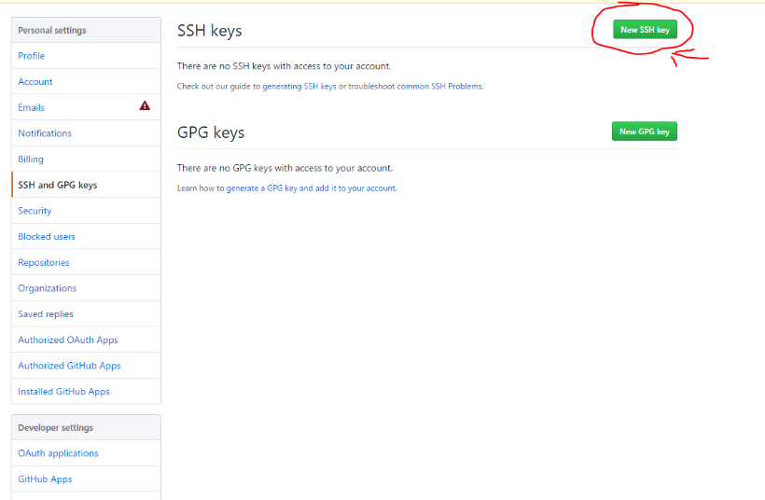

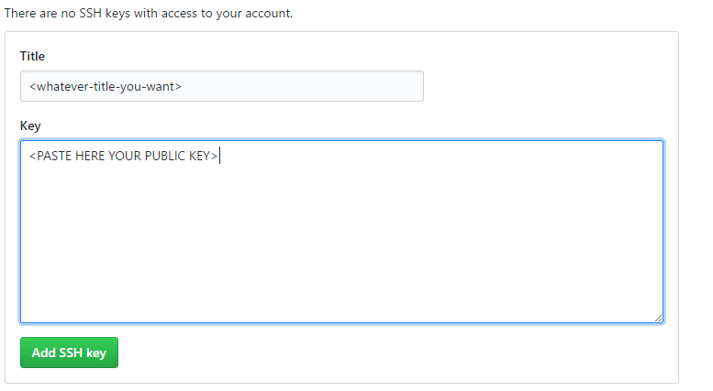

1. A
2. Clone [git@github.com:ZeroToHero-2017/gitWork.git](mailto:git@github.com:ZeroToHero-2017/gitWork.git) repo
3. Open Webstorm and make new Project using cloned sources
4. Edit w1.html and replace *<!-- CODE SNIPPET 1 -->* with <**p**>Hello from *<!-- your name -->*</**p**>